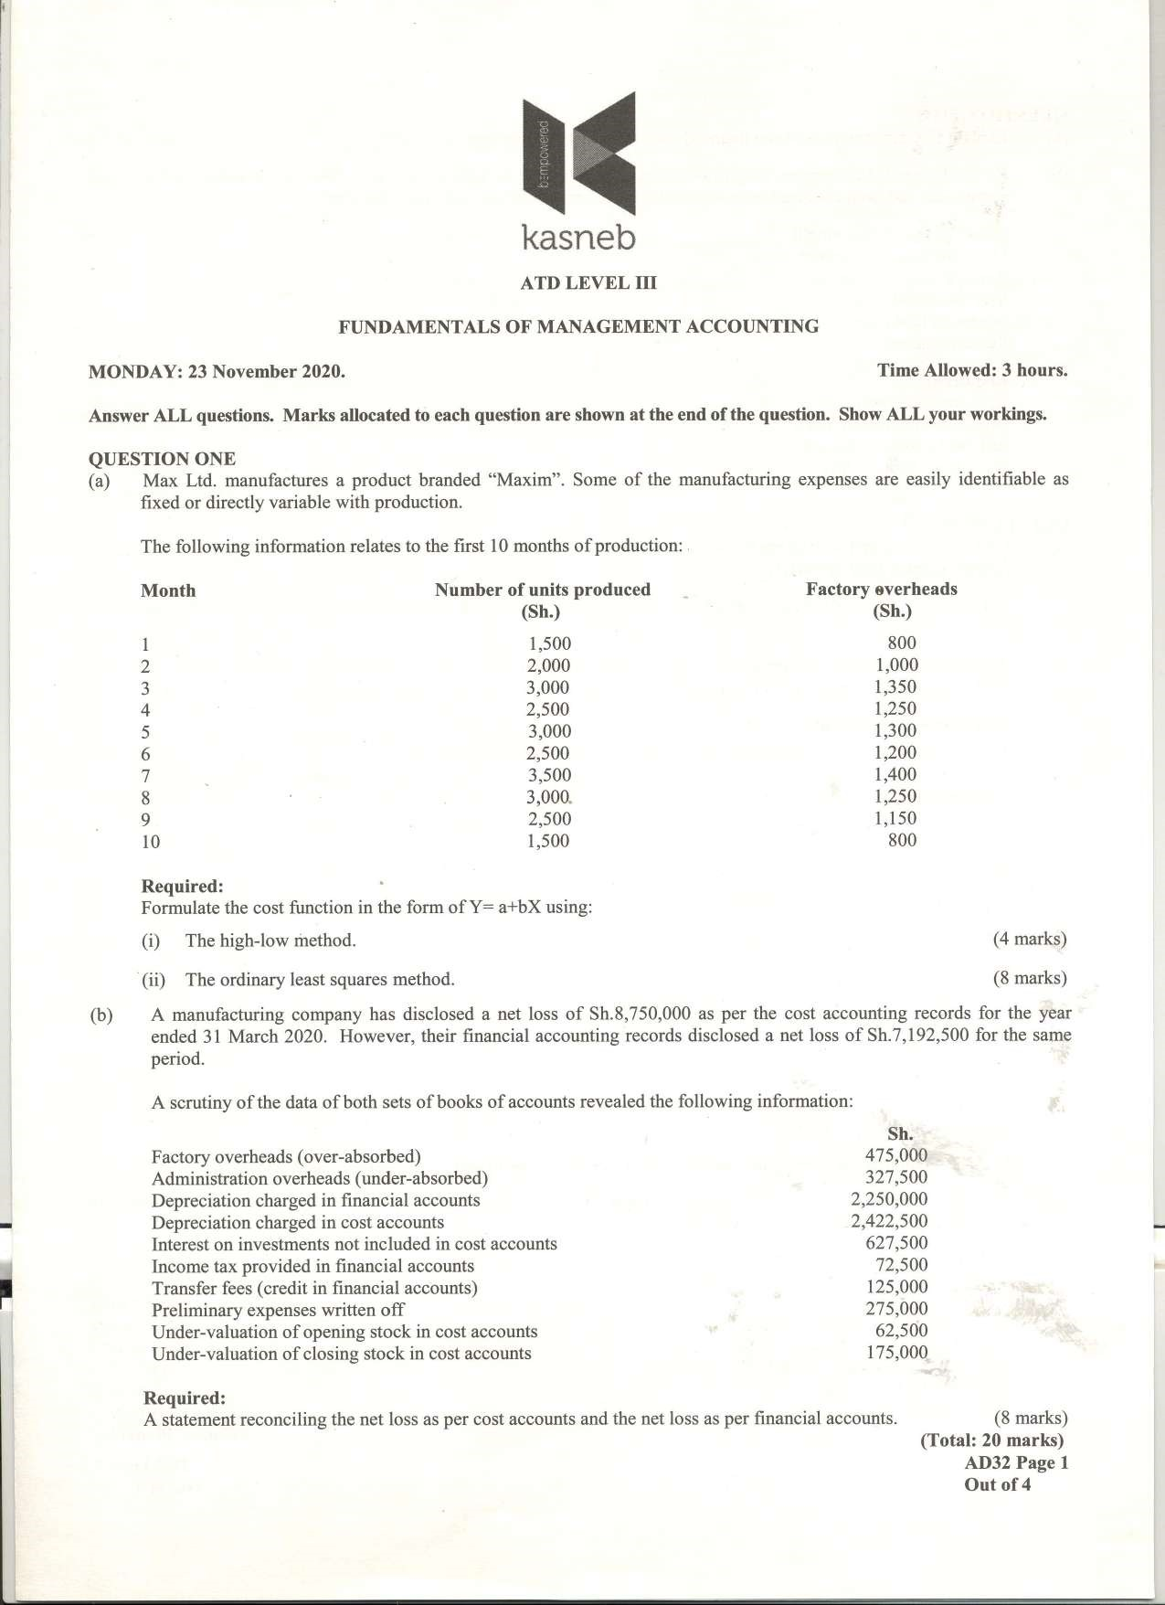

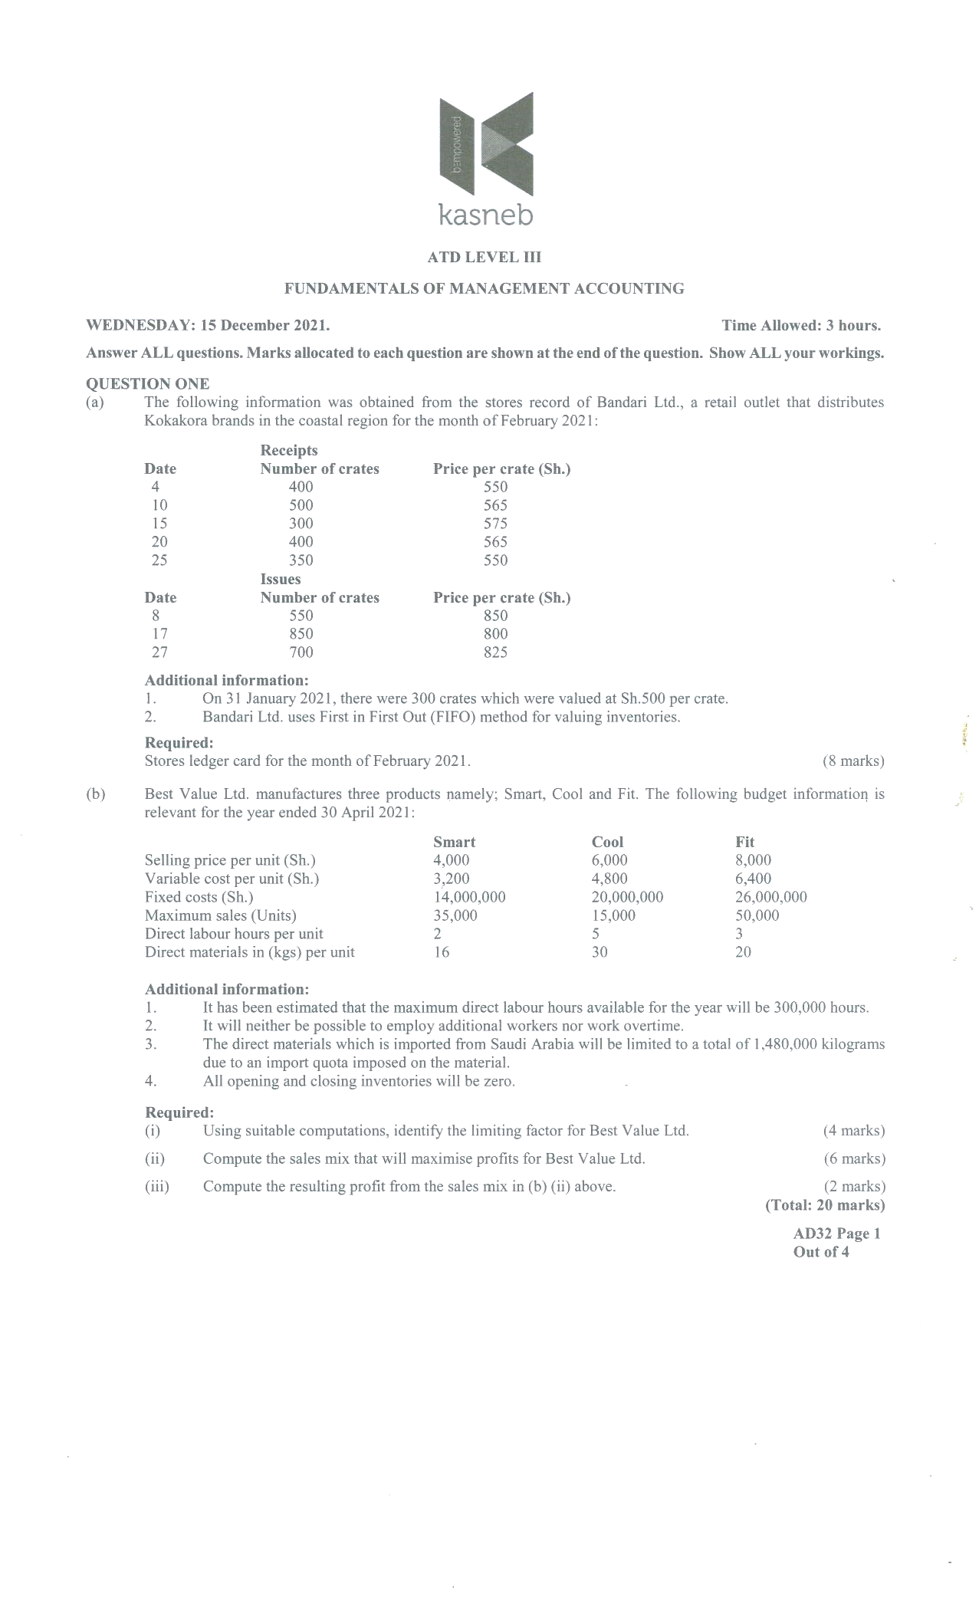

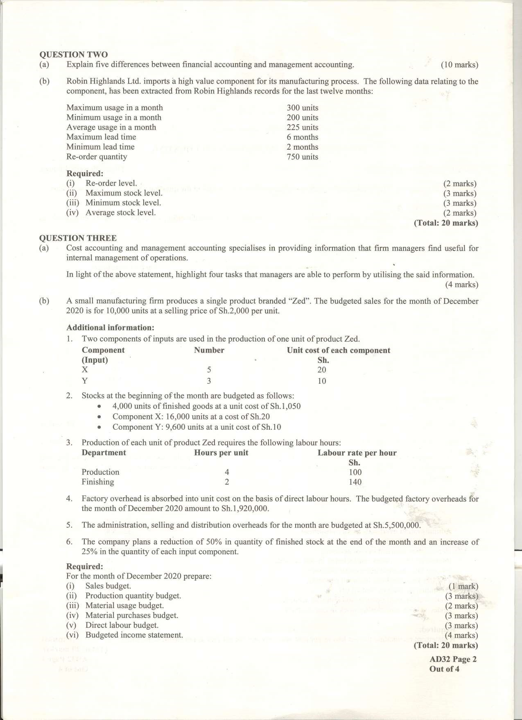

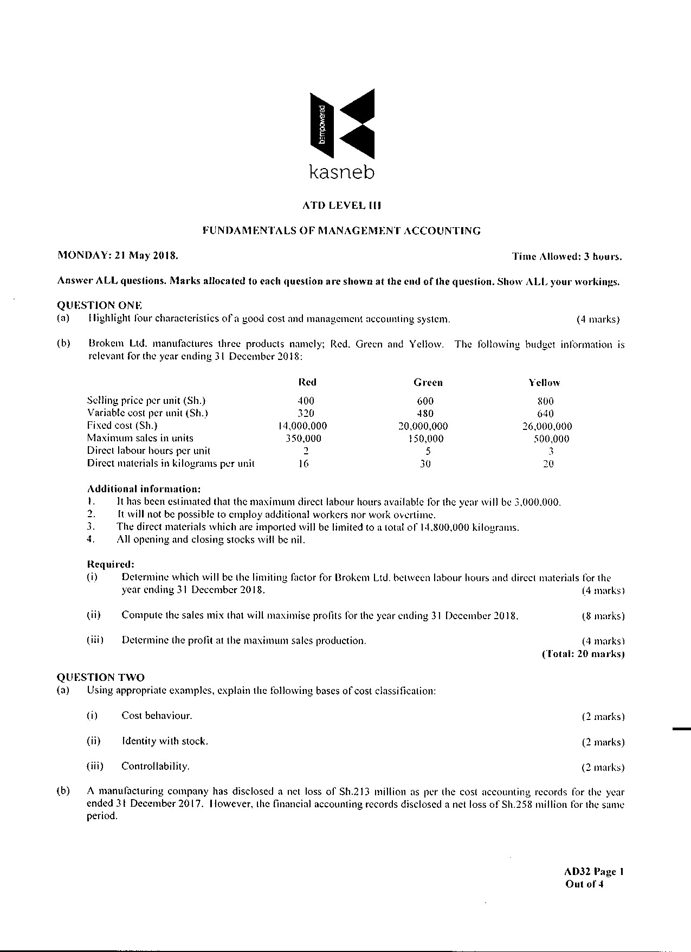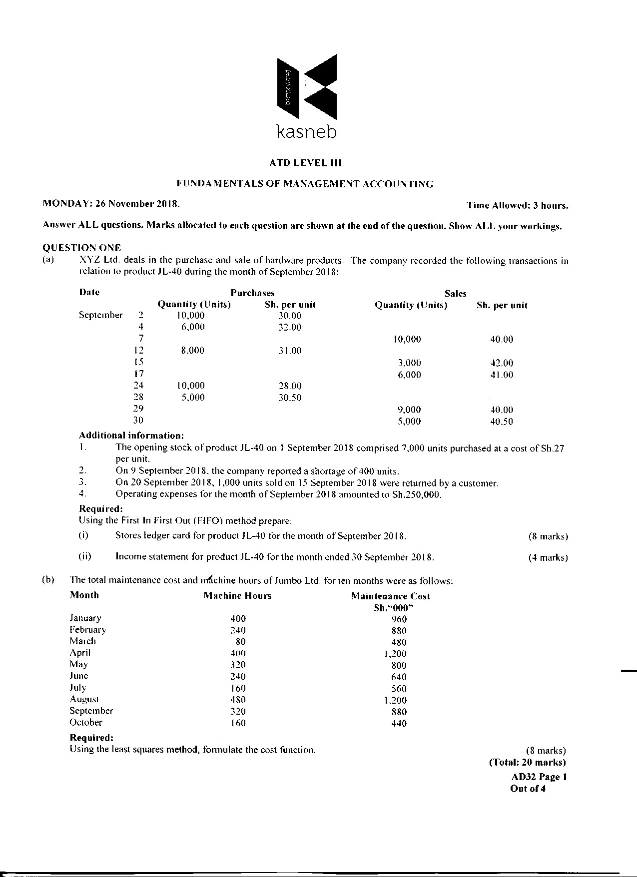

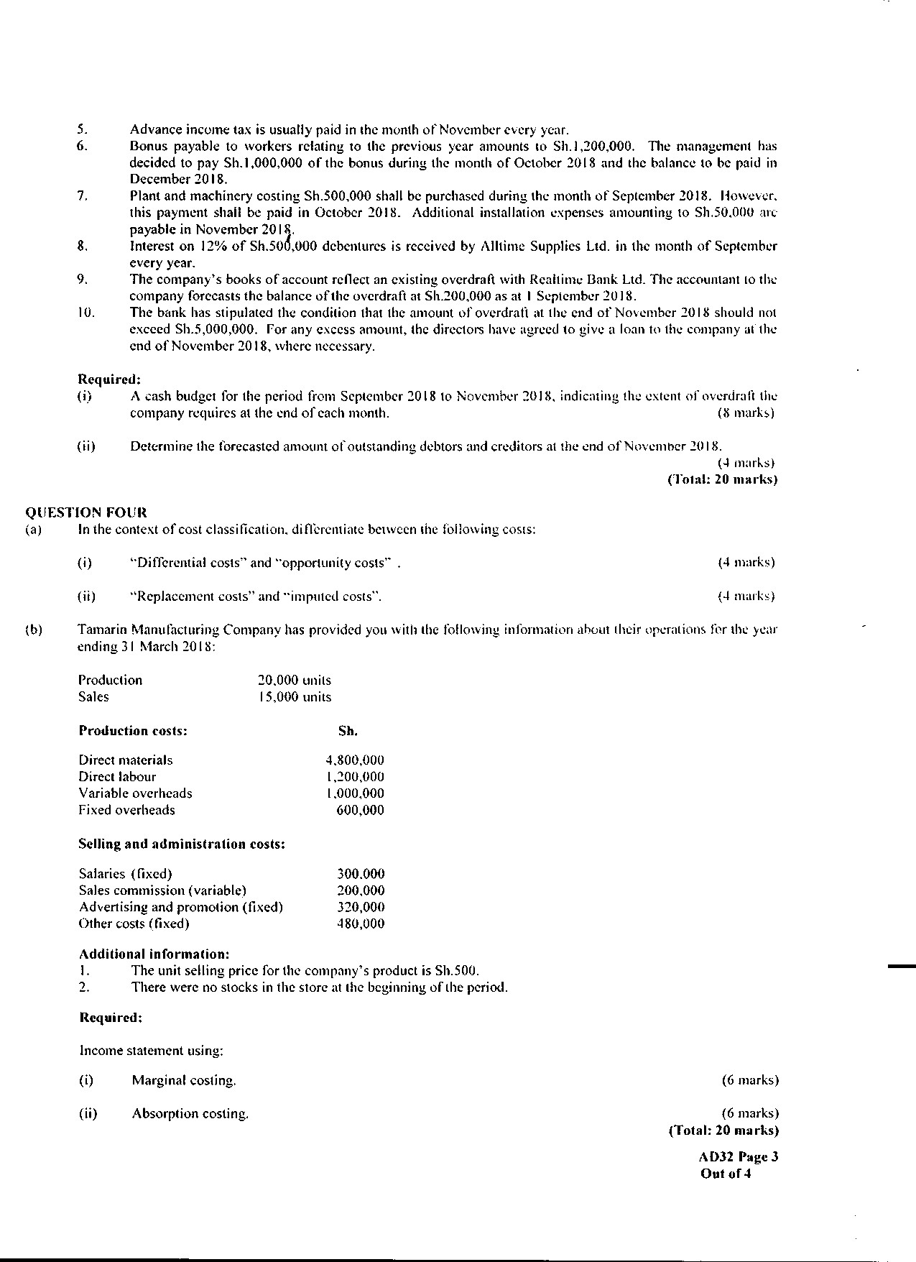

Jambo Limited manufactures ornaments for export trade. Jobs are allocated to two

operators, Amisi and Juma with bonus paid for hours saved.

In the month of February 2005 Amisi made 186 units and Juma made 210 units for

which the time allowed of 30 standard minutes and 25 standard minutes per unit

respectively was credited.

The basic wage rate was Sh.18 per hour for both employees. For every hour saved, a

bonus was paid at 20% of the basic wage rate. Hours worked in excess were paid at the

basic wage rate plus two thirds. Amisi completed his job in 44 hours and Juma

completed his job in 39 hours.

A basic week has 40 hours.

Required;

For each operator:

i) The amount of bonus payable; (2 marks)

ii) The total gross wage payable; (3 marks)

iii) The wages cost per unit (2 marks)

(c) Manane Ltd. places orders for one of the components used in its manufacturing process. The price of the component

has been fluctuating thus affecting the production of the final product and hence eroding market confidence of the

company’s clients. The company’s accountant has presented the following quantity ranges and respective price of

the component which he believes would result in a cost saving to the company:

Range number Quantity range Prices per unit of the component

Units Sh.

I 1 – 5,000 340

1 5,001 – 11,000 260

111 11,001 – 15,000 240

IV 15,001 – 19,000 200

V 19,001 and above 160

Additional information:

1. The company’s annual demand is 60,000 units.

2. The ordering cost per order is Sh.50,000.

3. The holding cost is 20% of the purchase price

4. The company practices continuous stock taking throughout the year.

Required:

Advise the company on the quantity range that would yield the highest cost savings